**Build a Custom Docker Image**

Docker Build

* The docker build command to build a custom docker image.

cd Docker

dockerbuild -t phpcode . -f Dockerfile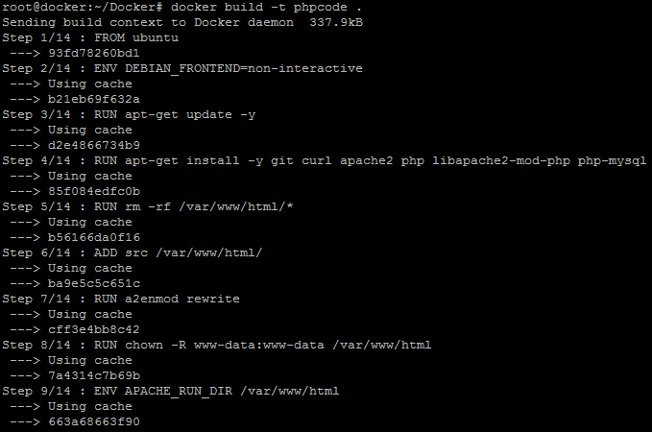

* Once the image is built, check the image using docker run command and then run it to initialize custom container on Docker host.

docker images

docker run -d --name phpcode -p 80:80 phpcode

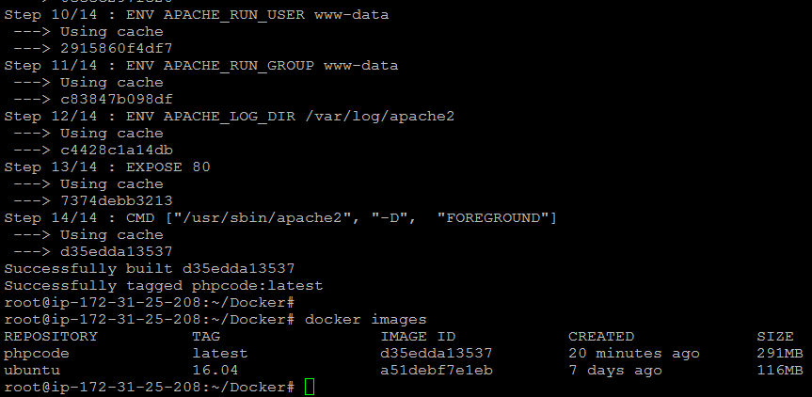

* Once the container is up and running, validate the connectivity using the **curl** command to see if **php code** is running on port 80 or not.